**Block Diagram Of Vehicle Security System:**

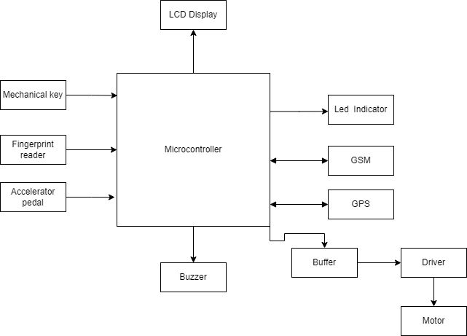

* Microcontroller: It is the Brain of the System which is responsible for all the monitoring and generating of input and output.
* Display: The output of the system will be displayed on LCD of SMS arrival status and configuration etc.
* Mechanical Key: It is a normal Key system to open the vehicle doors as well as start the engine.
* Fingerprint Reader: Fingerprint biometrics is one of the efficient, secure, cost effective, ease to use technologies for user authentication.
* Dc Motor: DC motors are part of the electric motors using DC power as energy source. These devices transform electrical energy into mechanical energy. The motor is connected through motor driver to the port of microcontroller.
* Buzzer: A buzzer or beeper is a signalling device, this buzzer beeps if any unauthorized person breaks the security system.
* GPS System: Global Positioning System can be used to provide security throughout the off-state condition of the vehicle. Even there is a possibility to drive away vehicle in switch off condition. There are cases where one vehicle can be totted in another higher vehicle. Thus, GPS prevents vehicle lifting and theft detection. Initially, on parking the vehicle current location will be stored. The Engine Control Unit (ECU) continuously monitors the engine function.
* GSM System: Global System for Mobile (GSM) that acts as an intermediate between owner and system. GSM is the worldwide accepted standard for digital cellular communication. GSM modems are most frequently used to provide mobile internet connectivity and many are used for sending and receiving Short Message Service.
* Driver: Used to convert the low current signal to high current signal and fed it to the motor.
* Buffer: A buffer is used to translate the voltage of the source to the voltage needed by the load.